**Project Design Phase-I**

**Solution Architecture**

|  |  |
| --- | --- |
| Date | 06 May 2023 |
| Team ID | NM2023TMID02598 |
| Project Name | Crime vision :Advanced crime classification with deep learning |

**Solution Architecture:**

**Crime classification with deep learning can be tackled using a supervised learning approach. In this approach, a deep neural network can be trained on a dataset of labeled crime data to predict the type of crime based on various features such as location, time, and characteristics of the crime. Here is a high-level solution architecture for an AI crime classification system using deep learning**

**Crime classification with deep learning can be tackled using a supervised learning approach. In this approach, a deep neural network can be trained on a dataset of labeled crime data to predict the type of crime based on various features such as location, time, and characteristics of the crime. Here is a high-level solution architecture for an AI crime classification system using deep learning:**

**Crime classification with deep learning can be tackled using a supervised learning approach. In this approach, a deep neural network can be trained on a dataset of labeled crime data to predict the type of crime based on various features such as location, time, and characteristics of the crime. Here is a high-level solution architecture for an AI crime classification system using deep learning:**

**Crime classification with deep learning can be tackled using a supervised learning approach. In this approach, a deep neural network can be trained on a dataset of labeled crime data to predict the type of crime based on various features such as location, time, and characteristics of the crime. Here is a high-level solution architecture for an AI crime classification system using deep learning.**

**Example - Solution Architecture Diagram:**

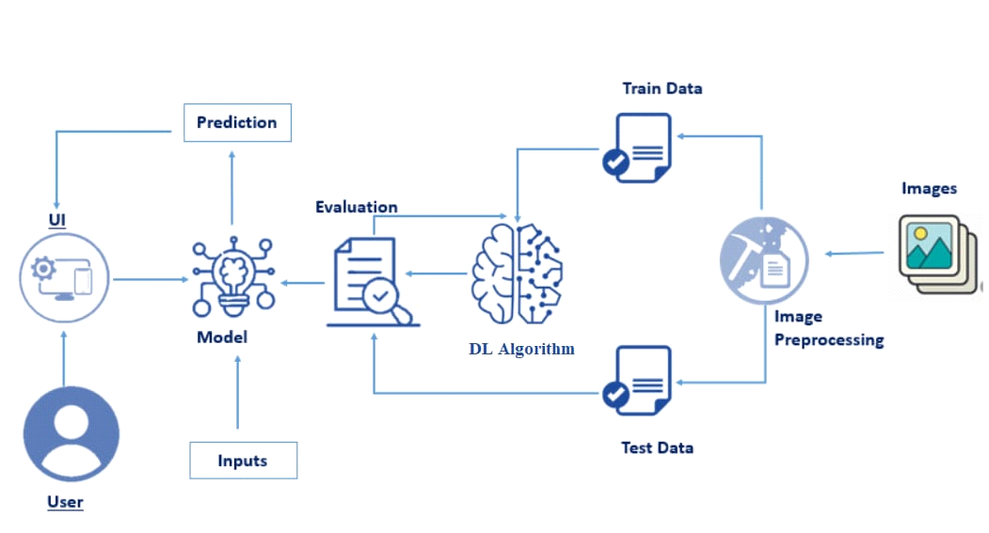

*Figure 1: Architecture and data flow of the voice patient diary sample application*

**Reference:** [**https://aws.amazon.com/blogs/industries/voice-applications-in-clinical-research-powered-by-ai-on-aws-part-1-architecture-and-design-considerations/**](https://aws.amazon.com/blogs/industries/voice-applications-in-clinical-research-powered-by-ai-on-aws-part-1-architecture-and-design-considerations/)